# Engineering Company



##### TO WHOM IT MAY CONCERN

**This is to Certify that Mr. <Name> S/O <fname> worked with us at White Oil Pipeline Project as a <Designation> from <From2> to <To2>.**

**During his stay with us we found him honest, punctual & hardworking.**

**We wish him well for the future and hope he get good work.**

**He left the job on his accord.**

**His services were no more required.**

**He was relived of the job on the completion of Project.**

**His services were terminated because of .**

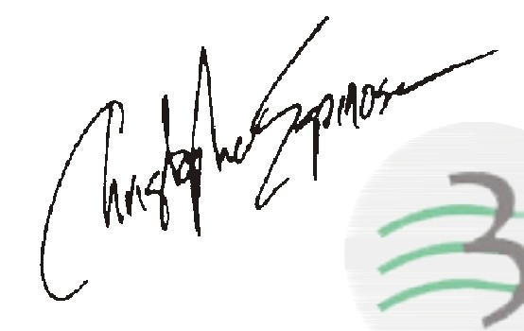

Project Incharge

**Address: 24-Main Industrial Estate, Kotlakhpat, Lahore. Phone: +92-42-5152033-4**

**Fax: +92-42-7651135**

**Website : www.briter.com.pk**